Himanshu Shekhar Murmu
244ca019

DBMS LAB -3

Q1. List all classroom with capacity more than 50.
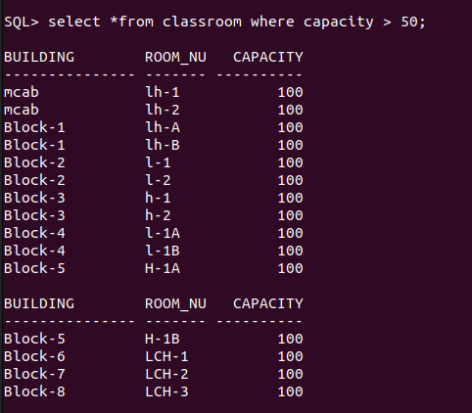

Q2. find the name of all instructor in the computer science dapartment.
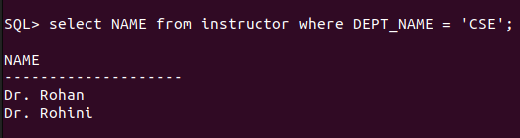

Q3. Retrieve the titles of all courses offered in the Spring semester of 2023.
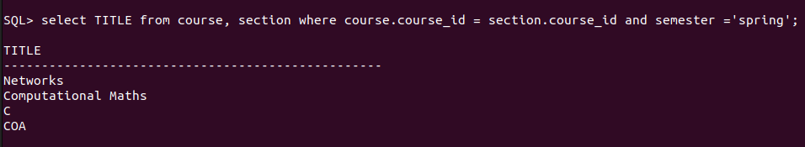

Q4. List the all student who have taken more than 100 credit points.

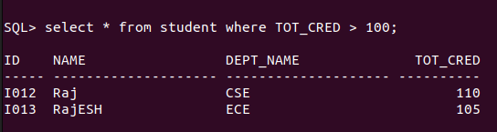

Q5. Find the names of all department with a budget greater than 1000000.
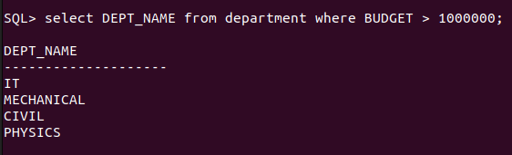

Q6. List all departments and their repective building.
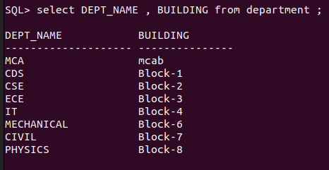

Q7. Find the name of all students enrolled in Biology department.
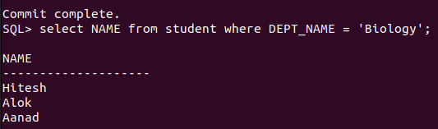

Q8. Retrieve the title of all the courses with credit 3.
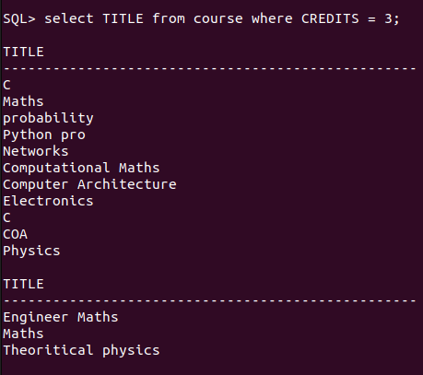

Q9. List all the instructors who do not belong to any department.
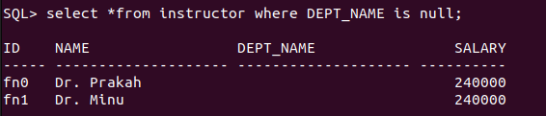

Q10. Find the total number of classroom in each building.
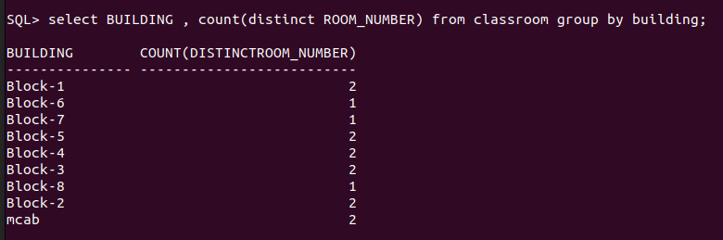

Q11. List all courses taught by the instructor with ID ‘10101’.
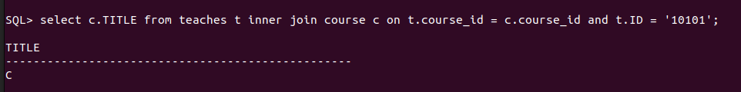

Q12. Find the total number of student enrolled in each department.
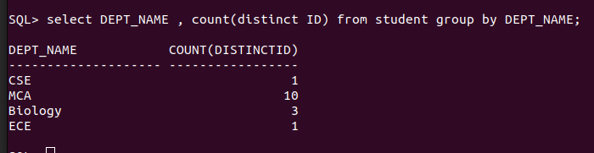

Q13. Retrieve the names of students who have taken the course "CS-101" and received an "A"
grade.

Q14. List all instructors who earn a salary greater than ₹50,000.
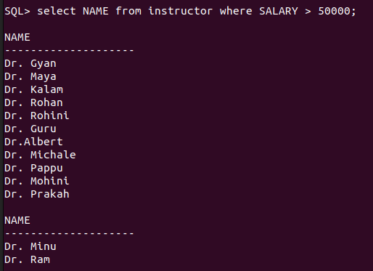

Q15. Find the average salary of instructors in each department.
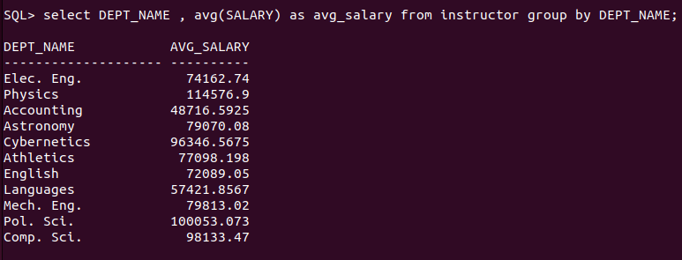

16. Retrieve the names of students who have not been assigned an advisor.

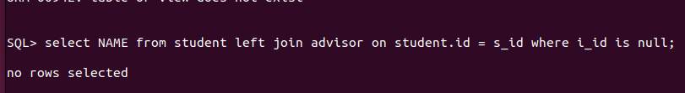

17. List all courses that have "CS-101" as a prerequisite.
18. Find the total number of sections taught in each building.
19. Retrieve the names of students who have taken at least one course in the "Fall"
semester of 2022.
20. List all classrooms that have not been assigned to any section.
21. List all courses offered by the "Mathematics" department.
22. Find the names of students who have taken courses in both "Fall" and "Spring"
semesters.
23. Retrieve the names of instructors who have taught more than 5 sections.
24. List all courses that have no prerequisites.
25. Find the average number of credits taken by students in each department.

